EYFS Addition
Early learning goals:
- Count reliably with numbers from 1 to 20, place them in order.
- Say which number is one more than a given number.
- Using quantities and objects, they add two single-digit numbers and count on to find the answer.
Recognise numbers up to 20 and understand the meaning of each number by recognising and knowing their clusters | Count on in ones and say which number is one more than a given number using a number line or number track to 20. | Begin to relate addition to combining two groups of objects using practical resources, role play, stories and songs. | Know that counting on is a strategy for addition. Use numbered number lines to 20.
Numicon shapes are introduced straight away and be used to:  • identify 1 more/less  • combine pieces to add  • find number bonds  • add without counting |  | Children can begin to combine groups of objects using concrete apparatus:  Construct number sentences verbally or using cards to go with practical activities.  Children are encouraged to read number sentences aloud in different ways:  - “Three add two equals 5”  - “5 is equal to three and two”  - “5 is the same as three and two”  Children make a record in pictures, words or symbols of addition activities.

EYFS Subtraction
Early learning goals:
- Say which number is one less than a given number.
- Using quantities and objects, they subtract two single-digit numbers and count back to find the answer.
Say which number is one less than a given number using a number line or number track to 20. | Begin to count backwards in familiar contexts such as number rhymes or stories. | Begin to relate subtraction to ‘taking away’ using concrete objects and role play. | Count backwards along a number line to ‘take away’
Number tracks can be introduced to count back and to find one less:  What is 1 less than 9?  1 less than 20?  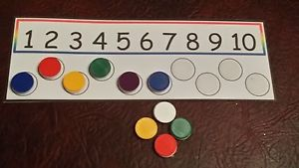 | Children make a record in pictures, words or symbols of subtraction activities.  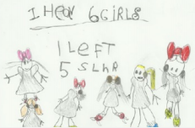 | Concrete apparatus is used to relate subtraction to taking away and counting how many objects are left.  Concrete apparatus models the subtraction of 2 objects from a set of 5.  Construct number sentences verbally or using cards to go with practical activities.  Children are encouraged to read sentences aloud in different ways “five subtract one leaves four” “four is equal to five subtract one” “four is the same as five subtract one”  Solve simple problems using fingers

EYFS Multiplication and Division
Early learning goals:
- They solve problems, including doubling, halving and sharing
- They solve problems, including halving and sharing.
Use pictorial representations and concrete resources to double numbers to 10. | Use concrete sources, role play, stories and songs to begin counting in twos, fives and tens. | Use pictorial representations and concrete resources to halve numbers to 10. | Begin to share quantities using practical resources, role play, stories and songs.
The link between addition and multiplication can be introduced through doubling. | ‘I have 5 pairs of socks on this line. How many socks do I have altogether? ‘ | “I have got a sandwich to share between two people.  Can you cut the sandwich in half?”  Children have a go at recording the calculation that has been carried out: e.g. by drawing pictures in groups or by arranging concrete apparatus into groups. | Sharing model:  I have 8 sweets. I want to share them with my friend. How many will we have each?

